
National University Of Modern Languages, Islamabad

User Experience Design (UXD)

Lab Task 14

Task: All lab

Name: Zulqarnain Hassan
Class: 6A Afternoon
Roll no: SP-21379
Assigned Date: 24 Apr 2025
Deadline: 15 May, 2025
Figma Design Link:
Marks Obtained
Remarks

Issues:

Lab 1
Task : X Clone
Link:https://www.figma.com/design/4ZcmSaB2ETQs7UcHMcxtml/Untitled?node-id=0-1&t=kDlS6UlXLy9ZcWmH-1
Page 01

Design Sample screenshot
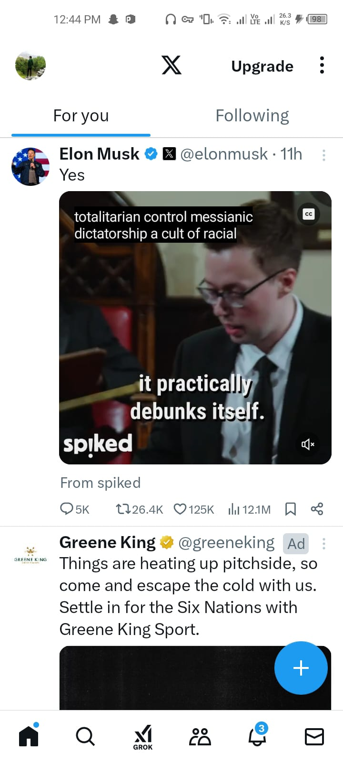
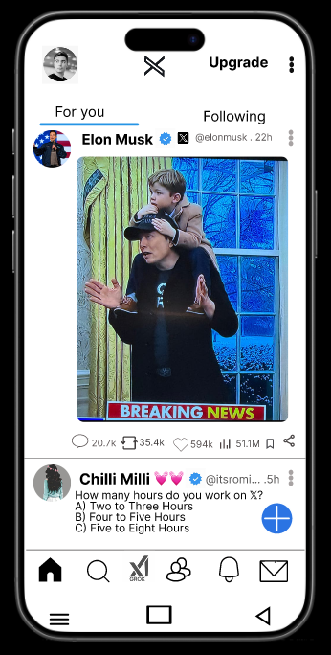

Page 2

Design Sample screenshot
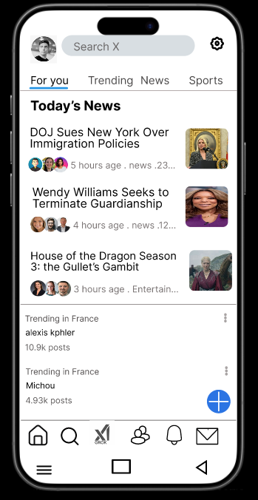
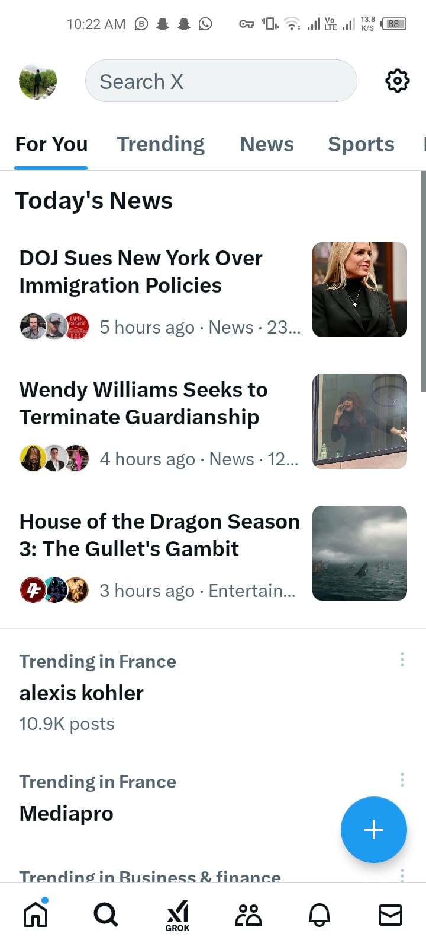

Page 3

Design Sample screenshot
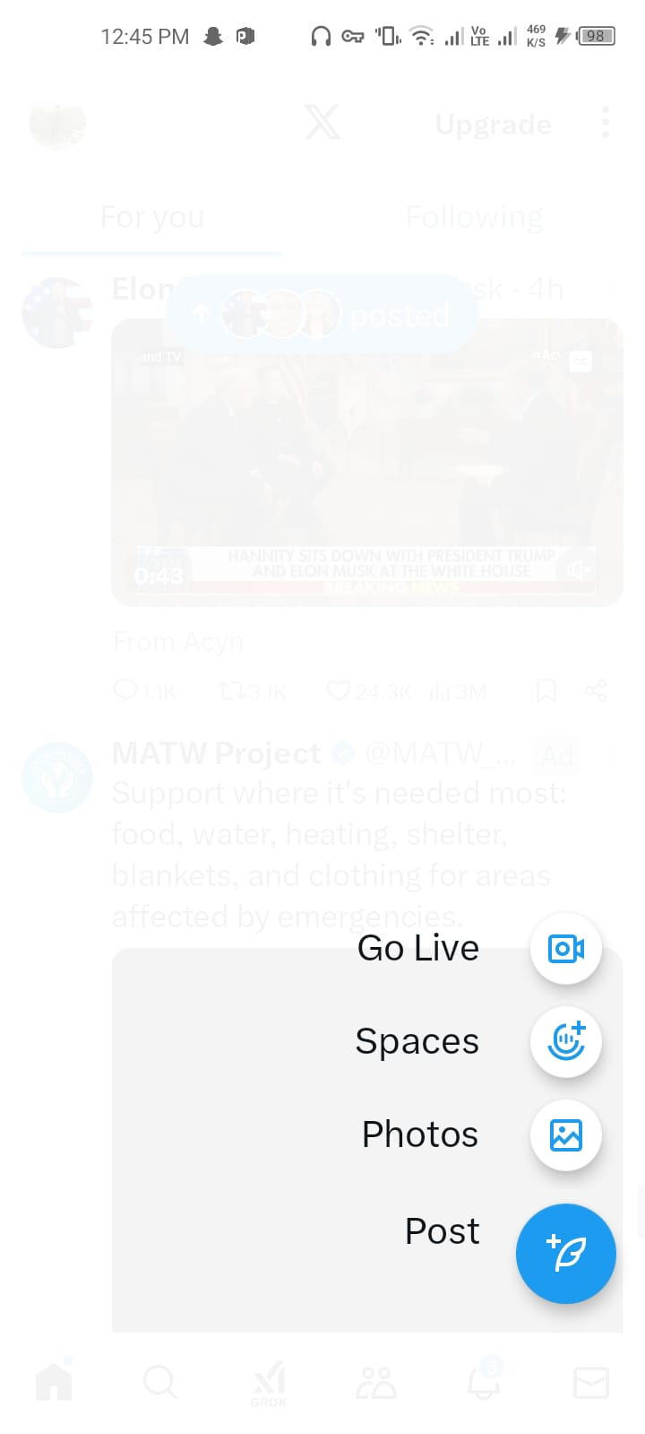
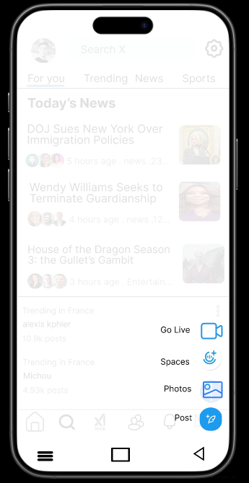

Wireframe
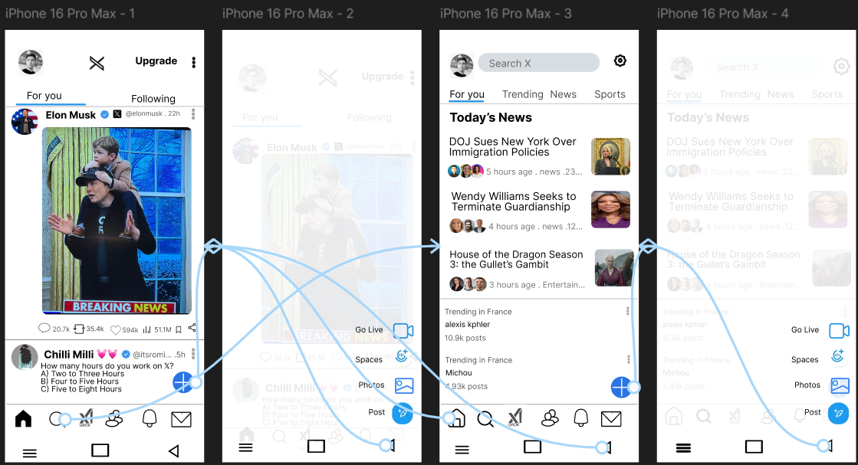

Lab 2
Task : Ptv website analysis

Observation (ptv).
Overall the pakistan television official website was good designed but have some drawbacks.
Drawbacks:(ptv):
- At the home page the three lines at the right top corner was not providing clear information. I was expecting some links but it has two sections about us and contact info
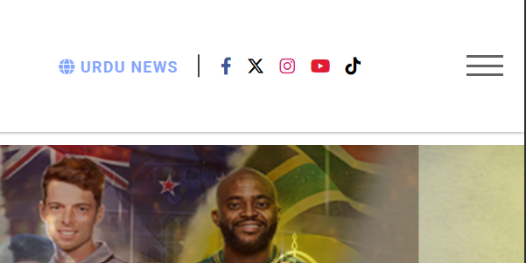

- When the app open in mobile the looks good specially the menu
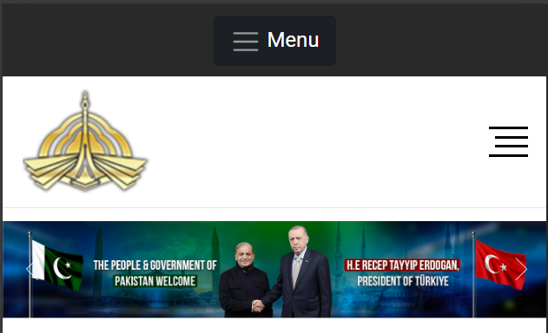
- The website's design appears outdated and does not reflect modern web design trends

Positive Things:
- The website has a straightforward, easy-to-understand layout, making it accessible to users of all ages.
- The text is easy to read due to clear fonts, which is user-friendly.
- The inclusion of images and videos adds visual interest, making the website more engaging.
- The consistent use of the PTV logo and colors helps in creating a recognizable identity.
- Information is divided into sections, which helps users find what they are looking for more easily.
Suggestion:
- Update the website to look fresh and modern.
- Make it simple for users to find what they are looking for with clear and organized menus.
- Ensure the website loads quickly by optimizing images and reducing unnecessary content.
- Use matching fonts and colors throughout the site for a professional appearance.
- Make sure the website works well on phones and tablets.

Lab 3
Task: University Website’s Information Architecture
Figma Design Link: https://www.figma.com/design/5jCtVxiOwlpKD2tyHX7IhI/Untitled?node-id=0-1&m=dev&t=cjHCkLIY5199f5kU-1

Home page Screenshots:
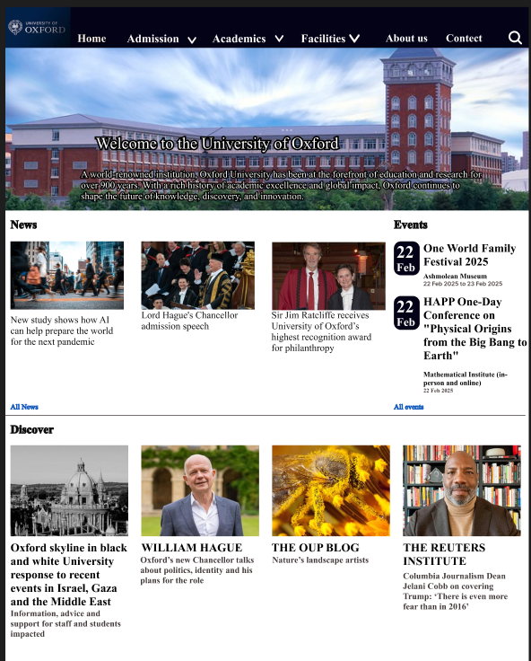

dropdowns


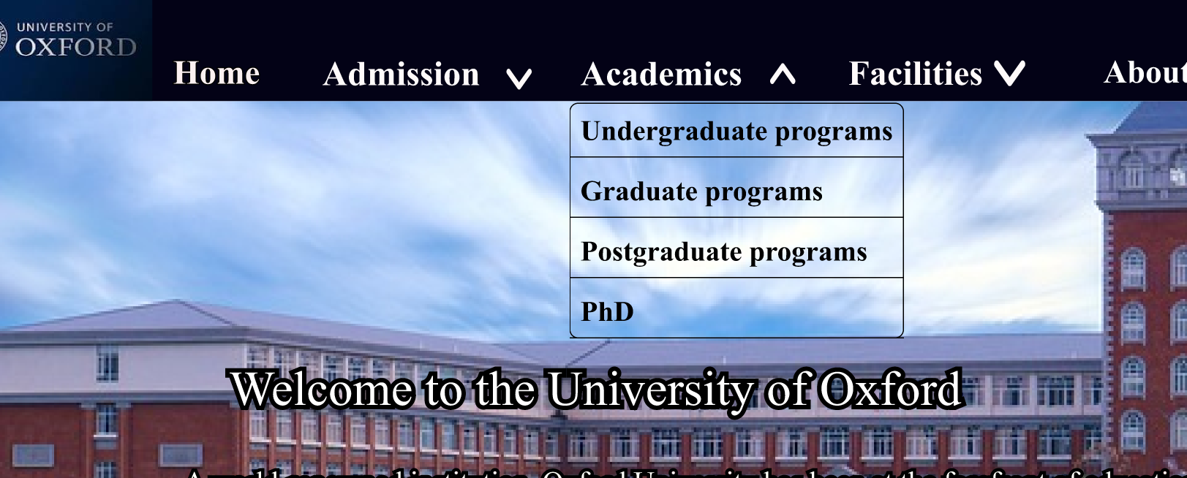



Lab 4
Task: Ecommerce mobiles App
Figma Design Link: https://www.figma.com/design/5jCtVxiOwlpKD2tyHX7IhI/Untitled?node-id=71-255&t=OWJIHIGqRCf5MwPc-1

Design Screenshots:
Page 1: Home screen
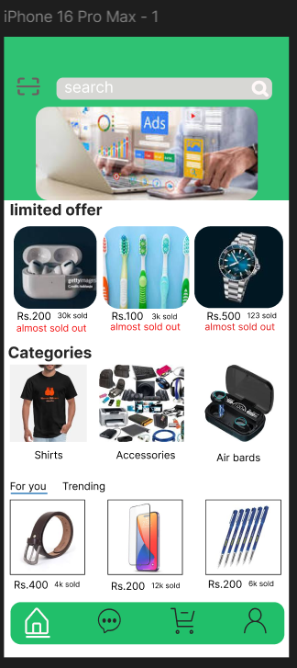
Page 2: Messages
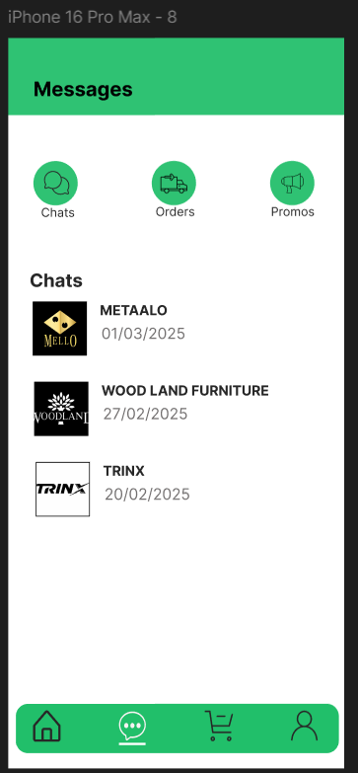
Page 3: My cart
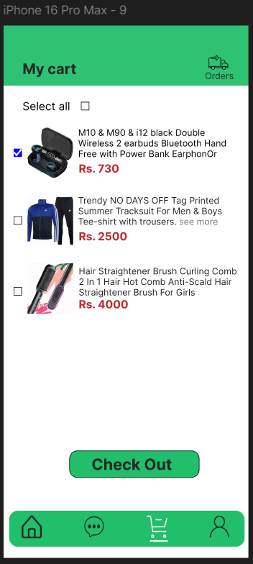
Page 4: Check out
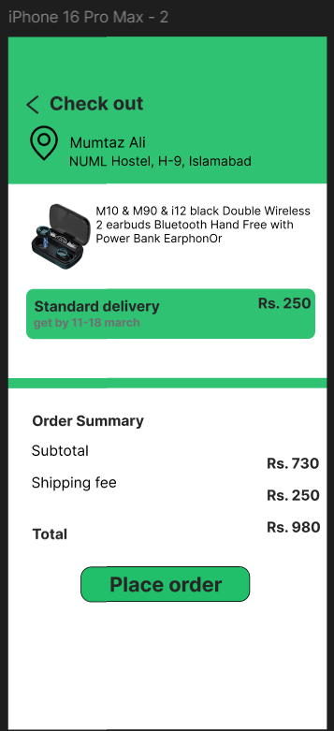

Page 5: Payment method
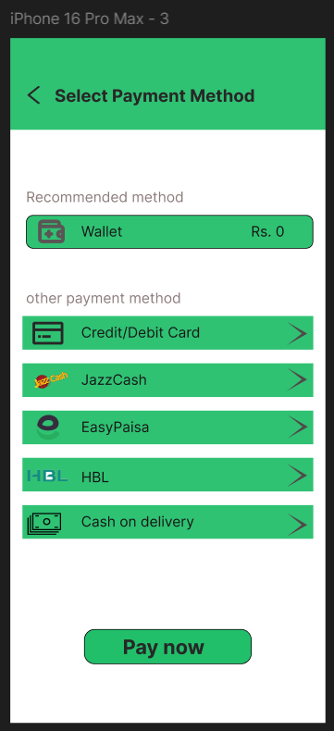

Page 6: Credit/Debit Card information form.
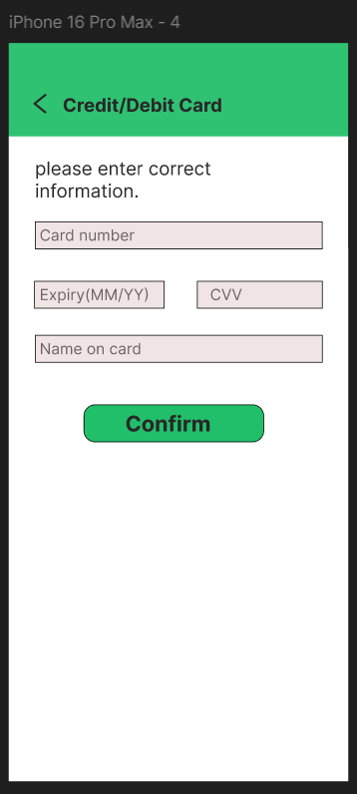
Page 7: Approval feedback (feedback type)
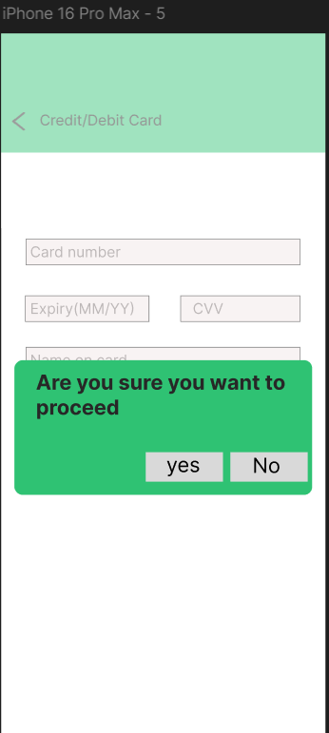
Page 8: Confirmation
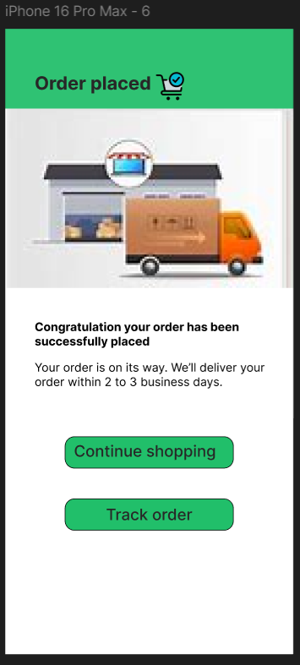
Lab 5
Task: Yale School Of Art (Website)
Figma Design Link: https://www.figma.com/design/5jCtVxiOwlpKD2tyHX7IhI/university_websit?node-id=123-248&t=f3srckdY2TemFlNv-1
Design Screenshots:
Page 1: Home screen
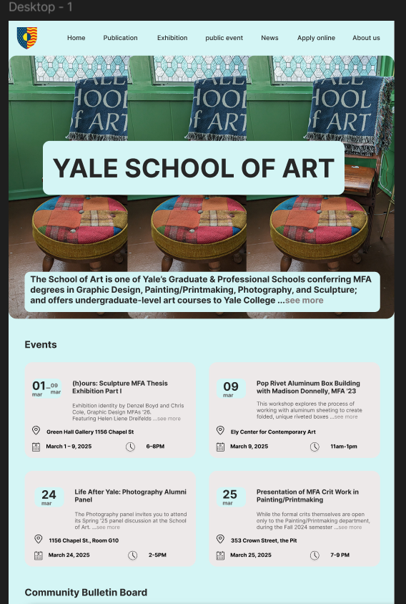
Page 1: Home screen continue
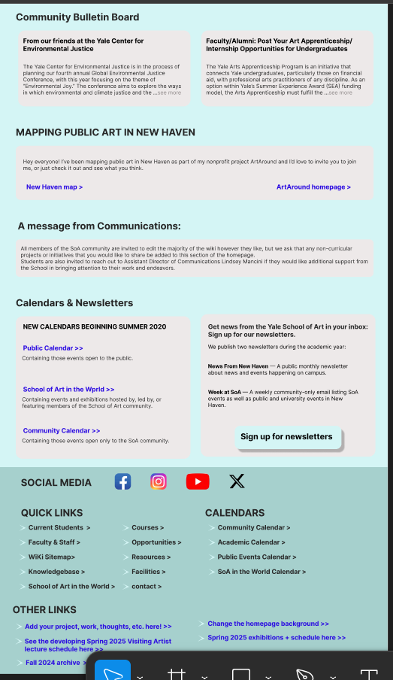
Page 2: Publications
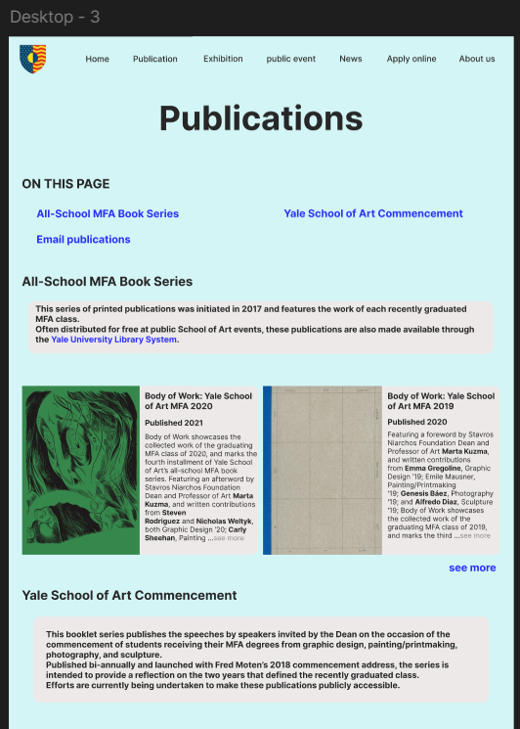
Page 2: Publications continue

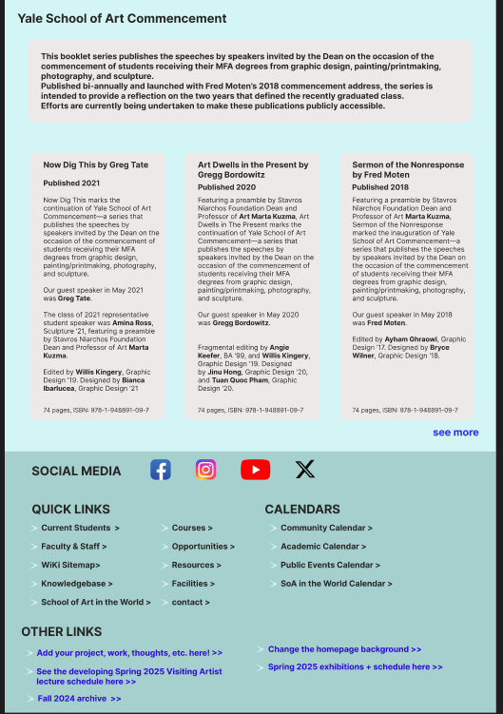
Page 3: Public Events
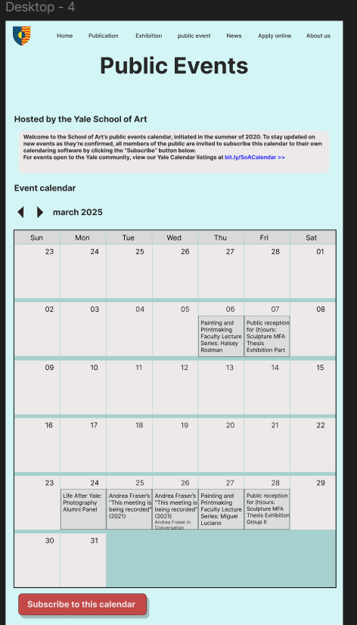

Page 4: Apply online
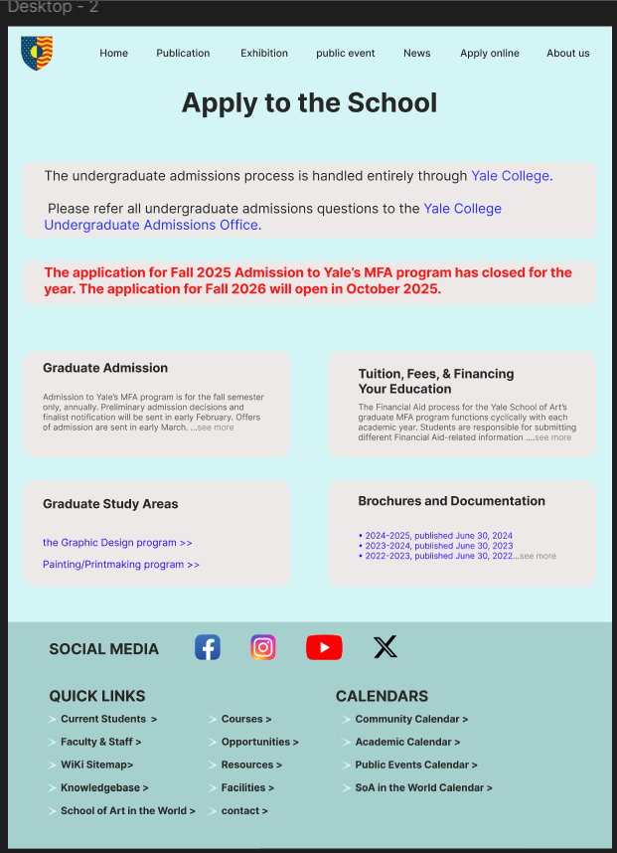
Lab 6
Task : Fellow design analysis
Figma : https://www.figma.com/design/X90L37G7SlrlidhpysvXgX/yale-school-of-art-design?node-id=0-1&t=oYaTI7G0Rlr2YsfY-1

1. Visual Design (According to Trend)
Problems:
- The school name is not looking well placed.
- The design is clean but lacks uniqueness or modern interactive elements.
- The event calendar section looks slightly outdated and could benefit from a more engaging UI.
- Some sections feel crowded, affecting the aesthetic appeal.
- Icons are not visible and text color is also mixing with the background color (on the calendar).
Recommendations:
- School name should be placed below the menu bar over the hero image.
- Introduce more white space to give a modern feel.
- Use subtle animations or hover effects for interactivity.
- Improve the event calendar UI with better spacing and visual elements.
- Use clear and visible icons.
Screenshots:
1:
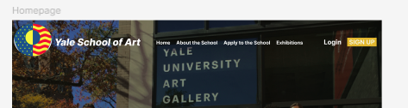
2:
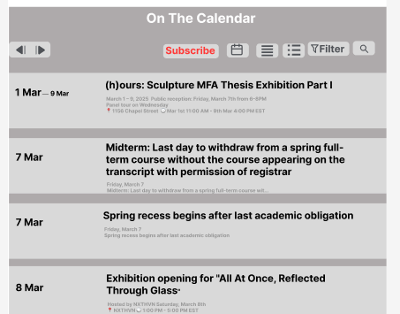
3:
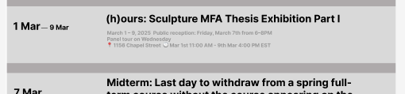

2. Clarity & Conciseness
Problems:
- Event descriptions are somewhat packed together, reducing clarity.
- Subscribe buttons don’t clearly indicate their purpose.
- Icons not properly align.
Recommendations:
- Space out event descriptions for better readability.
- Use tooltips or short labels to explain unclear buttons.
- Add icons where needed to improve understanding.
Screenshots:
1:
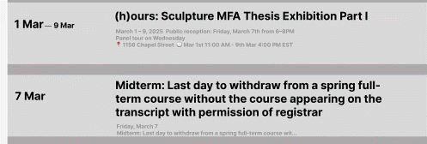
2:
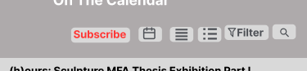

3. Learnability
Problems:
- The navigation bar follows a standard pattern but lacks clear visual feedback when hovering or selecting a page.
- Some buttons could be more intuitive (e.g., “Subscribe” in the calendar).
Recommendations:
- Implement hover effects to show interactivity.
- Use color or underline effects for selected menu items.
- Provide clear explanations or labels for buttons.
Screenshots:
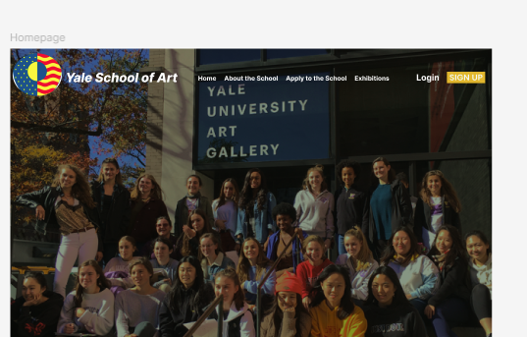

4. Navigation
Problems:
- The menu bar is not functional and lacks a strong visual hierarchy.
- No clear breadcrumbs or indicators showing the current page.
Recommendations:
- Highlight the active menu item for better orientation.
- Consider adding breadcrumbs for deeper navigation.
- Ensure all links are clearly visible and accessible.

5. Grids
Problems:
- The page follows a grid structure, but some sections feel misaligned.
- The event list looks cramped, reducing readability.
Recommendations:
- Maintain a consistent grid for spacing across sections.
- Adjust padding and margins to balance content.
- Ensure event listings have uniform spacing.
Screenshots:

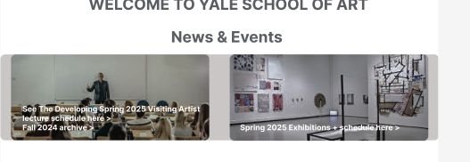

6. Alignments
Problems:
- Some text elements and buttons seem slightly off in alignment.
- The event section could be better spaced for consistency.
Recommendations:
- Align text elements properly within their containers.
- Use a consistent margin and padding system.
- Ensure the event list follows a proper grid layout.
Screenshots:
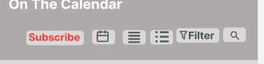

7. Color Scheme
Problems:
- The color scheme is mostly neutral but lacks contrast in some areas.
- The “Subscribe” button doesn’t stand out enough.
Recommendations:
- Increase contrast in areas where text blends with the background.
- Use a more vibrant color for the call-to-action buttons.
- Ensure accessibility by checking color contrast ratios.

8. Typography Analysis
Problems:
- Some text sizes are inconsistent, making the design feel unpolished.
- Event details appear cramped, reducing readability.
- Recommendations:
- Use a consistent font hierarchy (headings, subheadings, body text).
- spacing in the event section for better legibility.
- text is not too small for accessibility purposes.

9. Readability Analysis
Problems:
- Text inside buttons and event details are slightly small.
- Some sections feel cluttered, making it harder to read at a glance.
Recommendations:
- Increase font size for event descriptions.
- Space out text elements to reduce clutter
- Ensure sufficient contrast between text and background.

10. Major Issues
- Cluttered event section affects readability and usability.
- Navigation lacks clear indicators for the active page.
- Low contrast buttons make some interactive elements hard to notice.
- Inconsistent alignment and spacing create a slightly unpolished look.

11. Recommendations
- Improve contrast and color choices for accessibility.
- out event listings for better readability.
- Use proper text alignment and consistent font sizes.
- navigation items to enhance user orientation.
- Improve the visual appeal of the calendar section.

12. Conclusion
The website is well-structured with a clear focus on usability. However, minor design issues such as spacing, contrast, and readability affect the overall experience. Implementing the above recommendations will enhance clarity, engagement, and accessibility, making the site more user-friendly and visually appealing.

Lab 8
Task: NewsPaper app
Figma Design Link: https://www.figma.com/design/5jCtVxiOwlpKD2tyHX7IhI/university_websit?node-id=212-181&t=etJ5vMpIwhtkswAR-1

Design Screenshots:
main screen
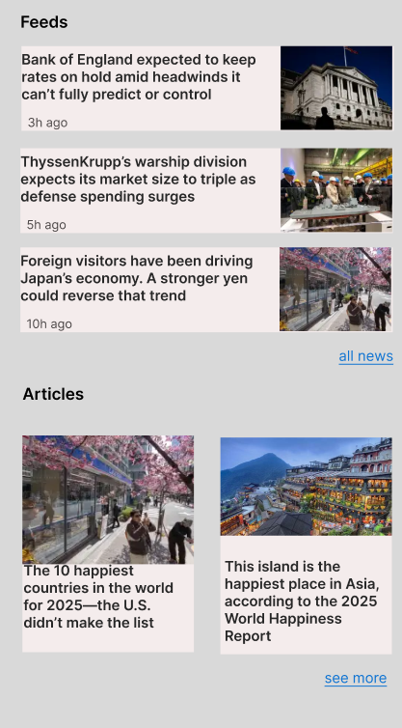
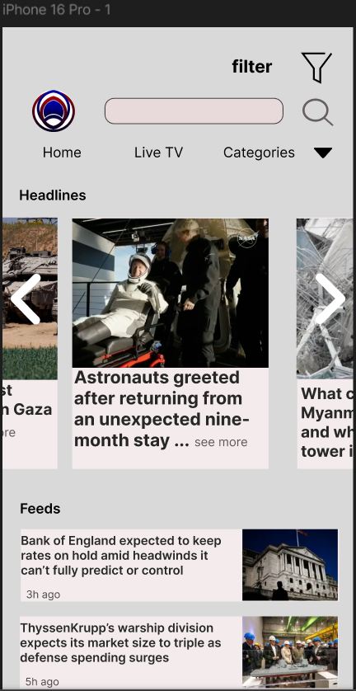
Hover: with the menu bar.
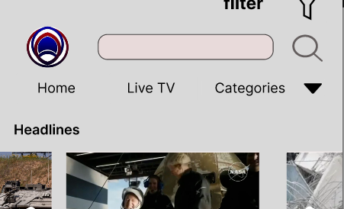

Dropdown: with categories
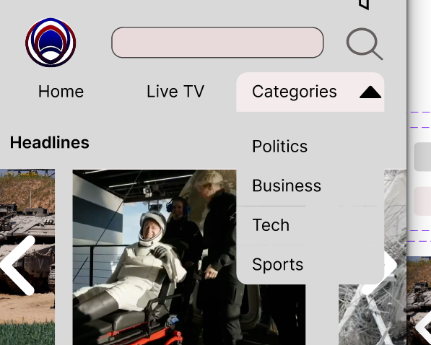
Filter:
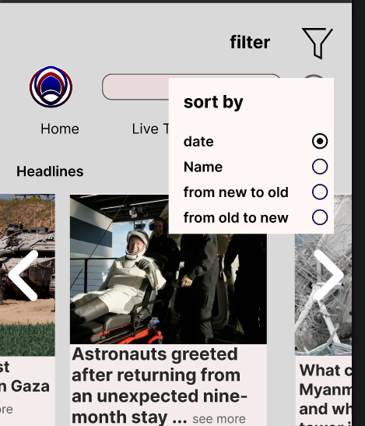

Lab 9
Task: Kid game app
Figma Design Link: https://www.figma.com/design/5jCtVxiOwlpKD2tyHX7IhI/university_websit?node-id=228-213&t=wYSv06nqf2XhsdhD-1
Page 01:
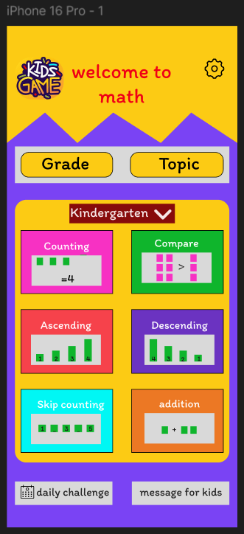
Page 2:
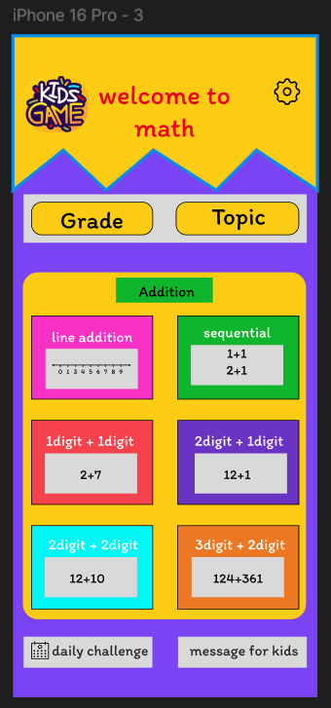

Page 3:
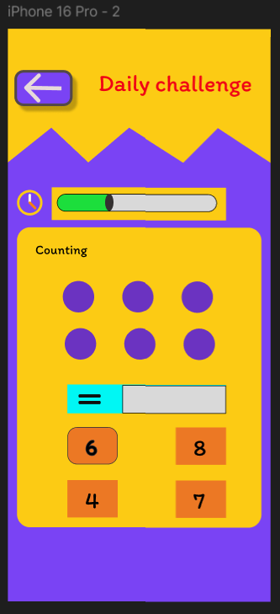

Page 4:
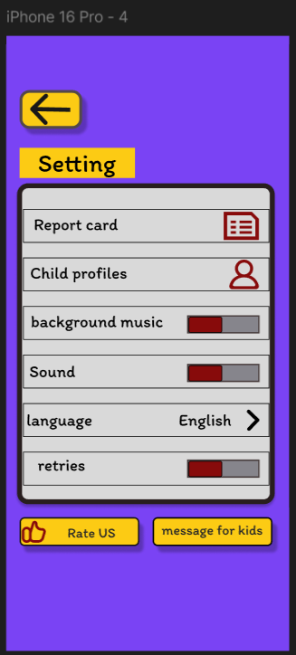
Lab 10
Task : Mart app
Figma link: https://www.figma.com/design/5jCtVxiOwlpKD2tyHX7IhI/university_websit?node-id=250-800&t=Mk8gCGxMpq2fFuA5-1

Screen 1
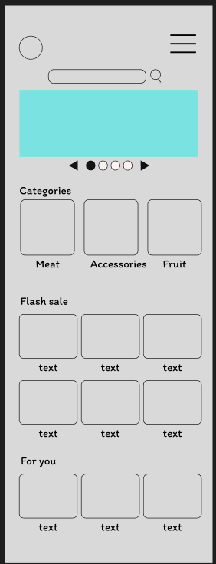
Screen 1
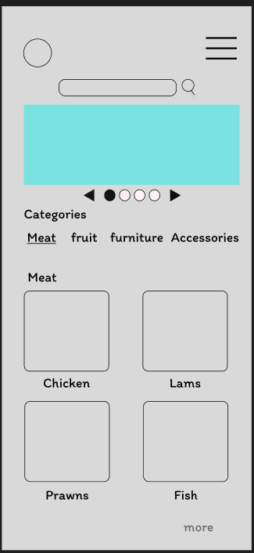

Screen 1
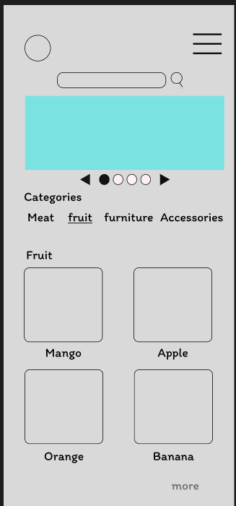

Screen 1
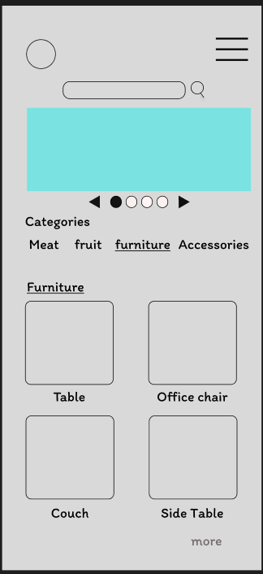

Screen 1
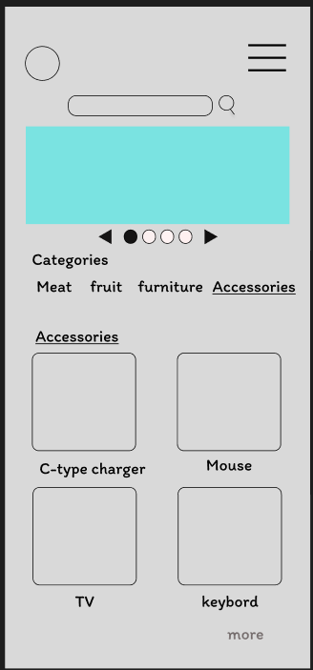

Lab 11
Task : Prototyping and iterative design
Figma link: https://www.figma.com/design/F27Ik1BSgWwqOQN4rPmwkj/Untitled?node-id=0-1&t=ImcmWWJaQDR3oFRf-1

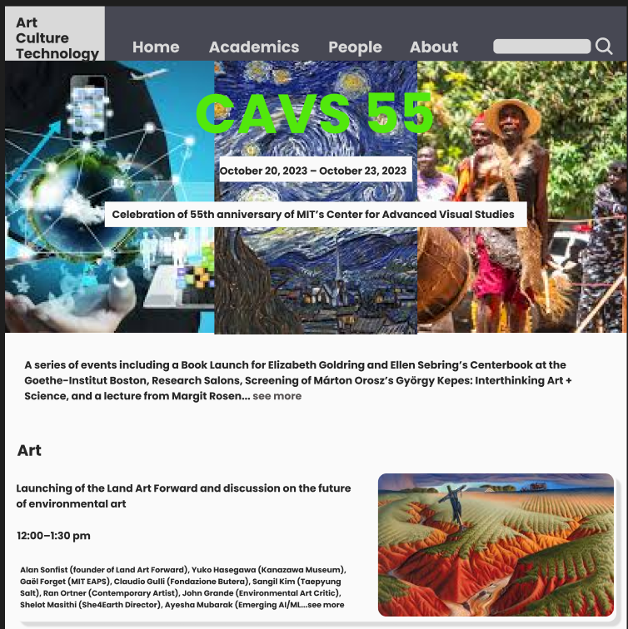
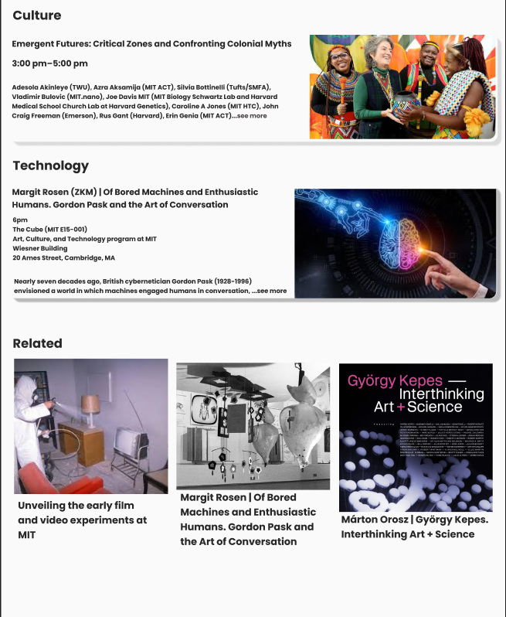

Lab Task 12
Task: Redesign LINGSCARS.COM

Figma Design Link: https://www.figma.com/design/4ZcmSaB2ETQs7UcHMcxtml/Untitled?node-id=114-92&t=yXLroktsjF7xXizF-1
Design Screenshots:
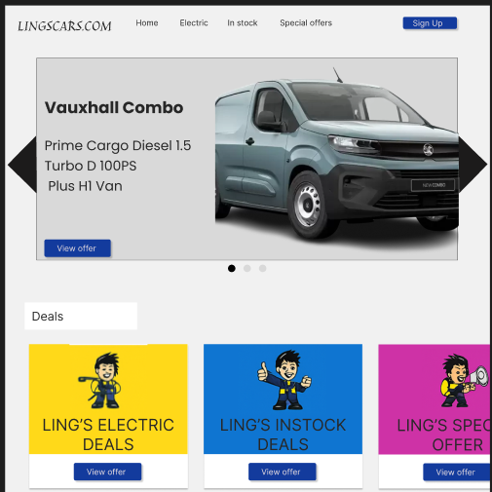
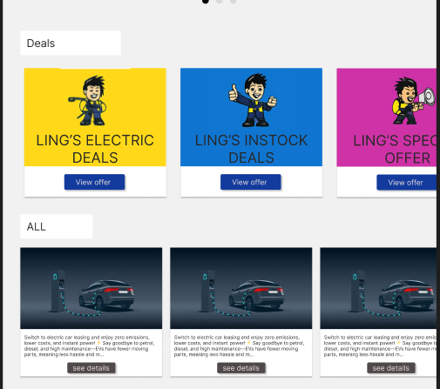

Lab Task 15

Task: E-Learning app design
Figma Design Link: https://www.figma.com/design/xnBbKMXApmgzpHYgU6IRgc/E-Learning-app?node-id=0-1&t=N2wcIqqO7ZJlvw7Y-1

Onboarding Screens
• Splash Screen: Shows the app's logo and name, creating a first impression when the app launches.
• Onboarding Screens: Briefly introduce key features like flexible learning, ease of use, and personalized study plans.
• Call-to-Action Buttons: Encourage users to continue, sign up, or log in after learning the app's benefits.

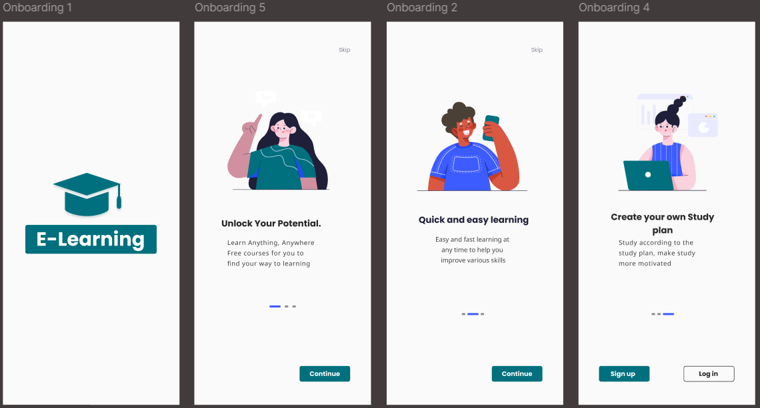

registration process
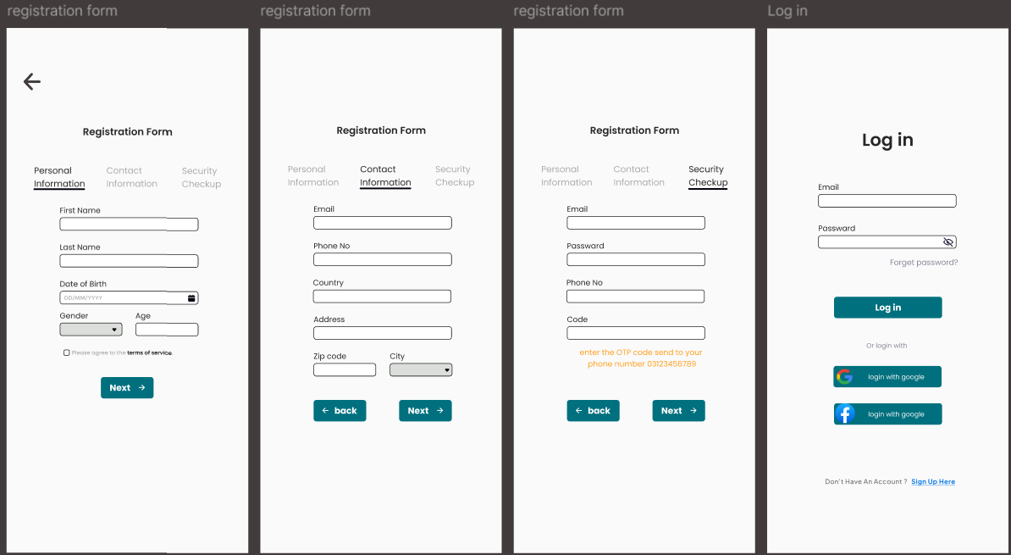
a step-by-step registration process with personal, contact, and security verification stages. It also includes a clean and intuitive login interface with social login options for easy access.

Home Screen
Displays daily learning progress, featured topics, live sessions, and popular courses for quick access.
Users can explore new categories and get personalized recommendations.
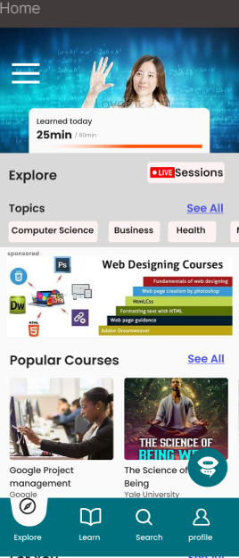

Learn Screen
Shows enrolled courses with progress tracking and options to view saved or downloaded content.
Helps learners stay organized and resume courses easily.
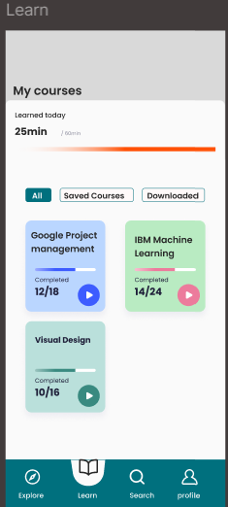
Search Screen
Allows users to search for courses with suggestions, recent activity, and popular keywords.
Offers a streamlined interface for discovering new learning opportunities.
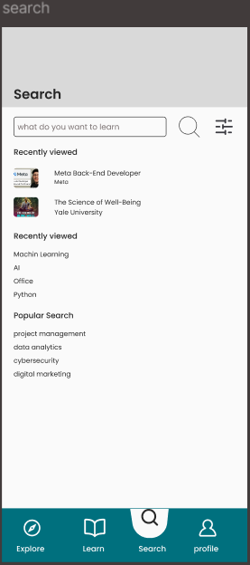

Profile Screen
Displays user information, achievements, and settings like payment method and logout.
Provides access to personal controls and account customization.
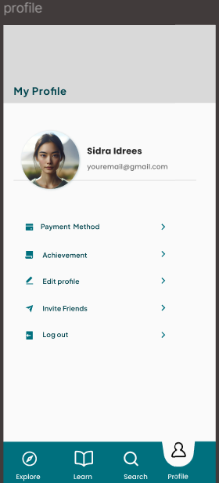
Search Result Screen
Displays a list of courses matching the user's query along with relevant details like course provider and duration.
Includes quick access to recently viewed items and popular search terms for easy navigation.
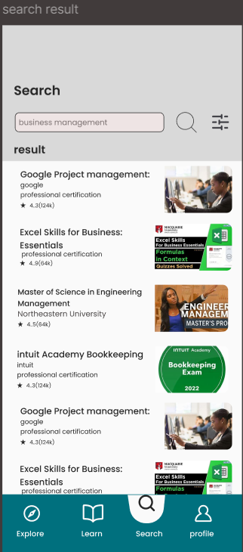
Filter on Search Result
Allows users to refine search results using filters like category, difficulty level, duration, or course provider.
Enhances the user experience by helping learners find the most relevant courses faster.
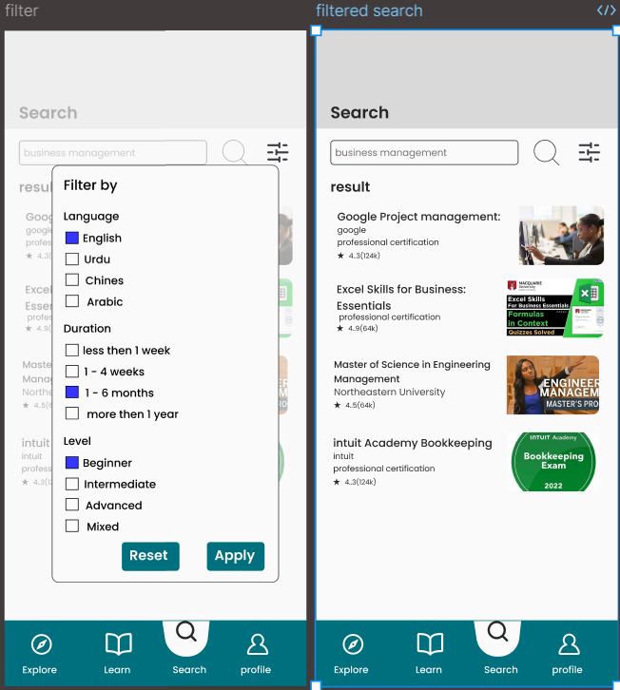
Log Out Screen
Accessed from the profile screen, it confirms the user's intention to log out of the app.
Ensures secure session end with a simple confirmation message and navigation back to the login screen.
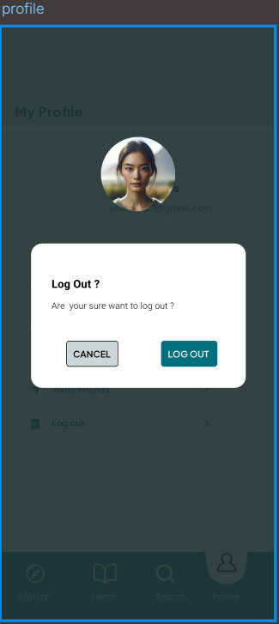

Edit Profile Screen:
Allows users to update their personal information such as name, email, profile photo, and password.
Ensures user profiles remain accurate and up-to-date with an intuitive editing interface.
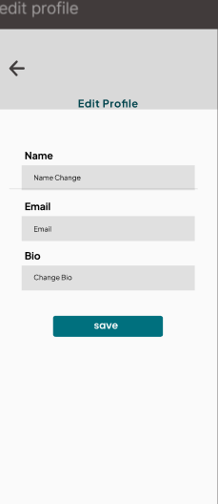
Achievement Screen:
Displays user accomplishments like completed courses, milestones, and badges earned through learning progress.
Motivates learners by visually tracking success and celebrating their achievements.
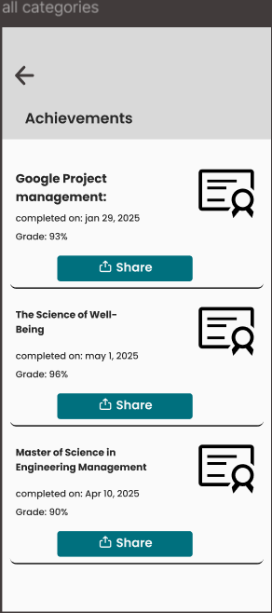
Live Session List Screen
Shows a list of ongoing and upcoming live sessions with key details like title, instructor, and start time.
Users can join live sessions in progress or set reminders for upcoming ones directly from the screen.
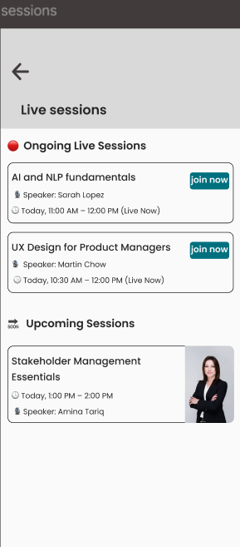
Live Session Streaming Screen
Displays the live video stream alongside an interactive live chat for real-time engagement with the instructor and peers.
Includes controls for volume, full screen, and a participant list to enhance the learning experience.
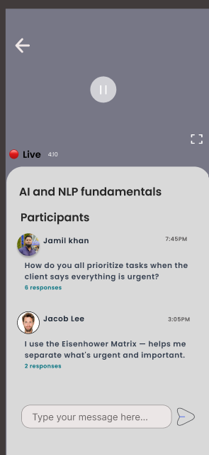
AI Assistant Chatting Screen
Provides a smart chat interface where users can ask questions and receive instant, AI-generated answers related to their courses.
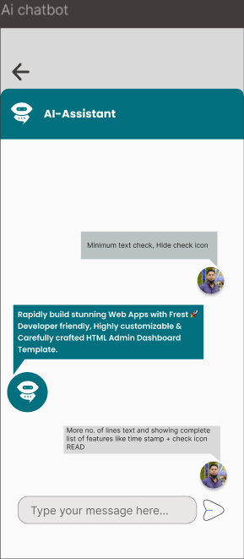

Course Category Screen
Displays a list of course categories like Programming, Design, Business, etc., each with a thumbnail and course count.
Users can tap a category to explore all related topics and available courses in that domain.

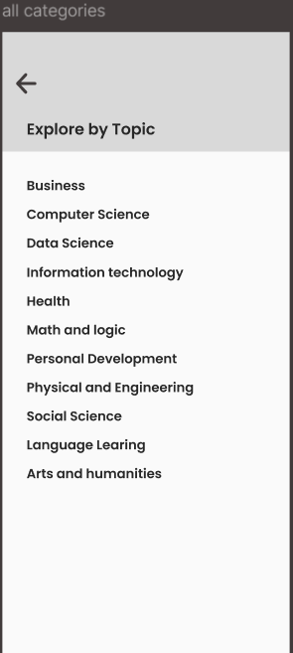
Course Details Screen:
Shows comprehensive information about the course, including title, price, duration, language, and difficulty level.
Also features a course description, instructor profile, and an enroll button for immediate access.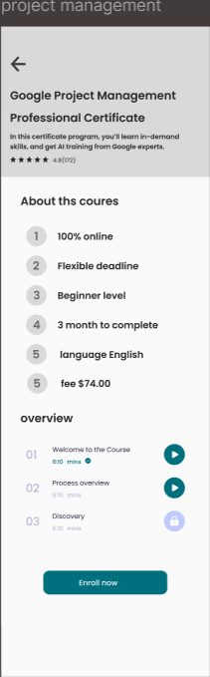

Demo Video Overview Screen
Provides a short preview video giving an overview of the course content, teaching style, and learning outcomes.
Helps users evaluate the course before enrolling, with controls for play, pause, and full-screen viewing.
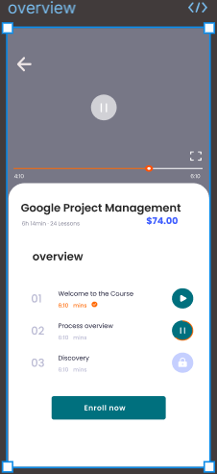

Payment Selection Screen
Displays various payment methods including Credit/Debit Card, Jazz Cash, EasyPaisa, and other wallets. Users can select their preferred option to proceed.
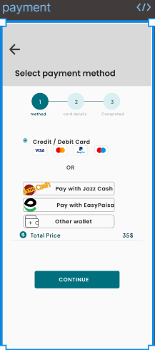
Card Details Screen
Allows users to enter card information such as Card Number, Expiry Date, and CW Number. Includes a toggle for saving card details for future use.
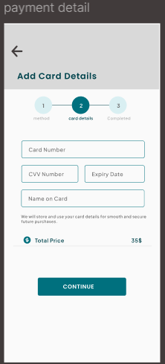
Transaction Completed Screen
Confirms successful payment with a congratulatory message and prompts the user to start their learning journey with a "START LEARNING" button.
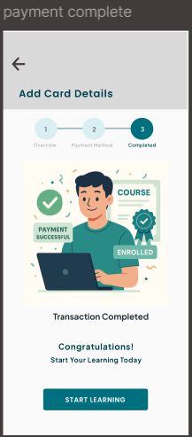
Course Overview Screen
Displays the course title (e.g., "Google Project Management") and organizes content by weeks. Includes sections for Notes, Assessments, and Discussions to track progress.
Provides a structured layout for each week (e.g., Week 01, Week 02) with placeholders for Notes, Assessments, and Discussions, allowing users to navigate and input data easily.
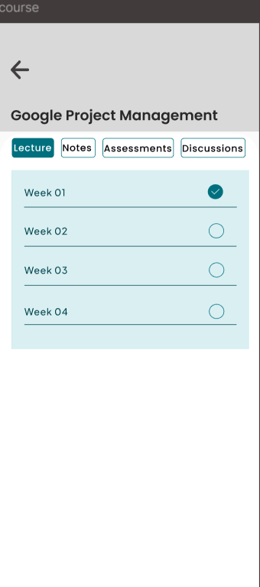
Video Lecture Screen
Displays the course title ("Google Project Management") and allows navigation between weeks (e.g., Week 1, Week 2). Shows the currently playing lecture (e.g., "Lecture 1: Introduction") with video playback controls.
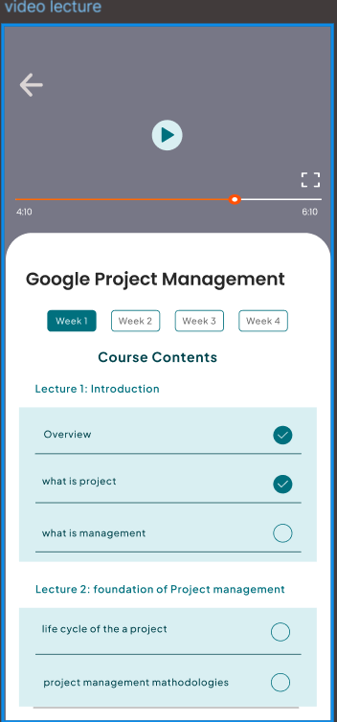

Notes Overview Screen
Displays a list of available lecture notes (e.g., "Introduction to Project Management," "Project Life Cycle") with brief descriptions. Includes a download icon (PDF) next to each note for offline access.
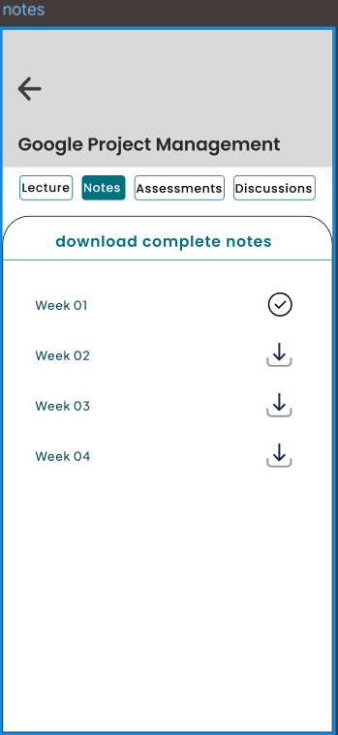
Quiz Screen
Presents timed multiple-choice or short-answer questions to test learners' understanding of the course material.
Includes progress tracking, instant feedback, and a score summary upon completion.
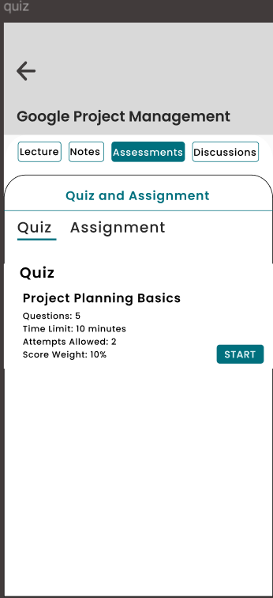
Assignment Screen
Displays assignment details such as instructions, submission deadline, and file upload options.
Allows users to submit their work directly and view feedback or grades from instructors.
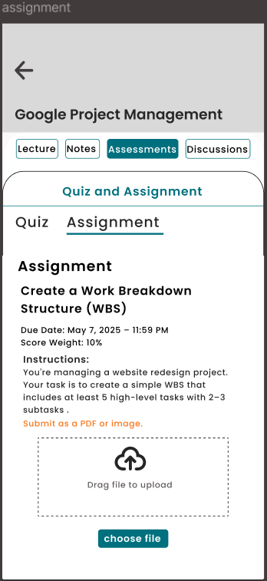
Peer Chat Screen
Enables real-time messaging with peers or instructors. Features a chat interface with sent/received timestamps, read receipts, and file-sharing options (e.g., PDFs, links). Includes a search bar to find past conversations.
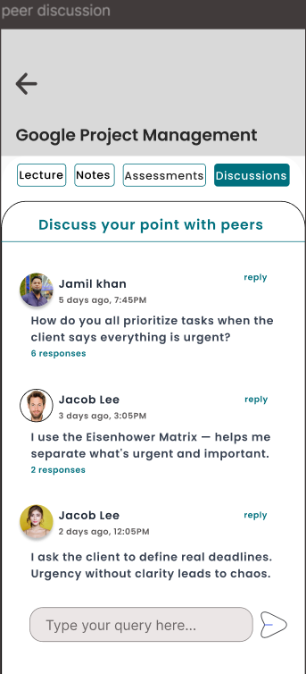

Computer Science Category Overview Screen
Displays a broad selection of popular courses and certifications (e.g., IBM Full Stack, Google Project Management) with icons, ratings (e.g., "41(103)"), and providers (e.g., Google, IBM). Users can filter by "All," "Popular," or "Professional Certification."
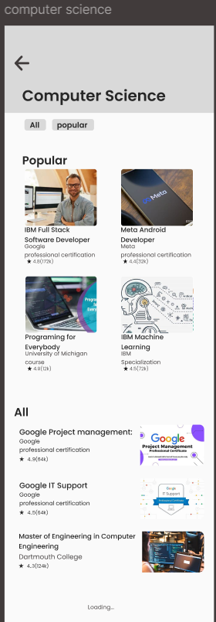
Message Screen
Shows a list of received messages from instructors, system notifications, or peers within the app.
Each message includes a sender name, timestamp, and a preview.
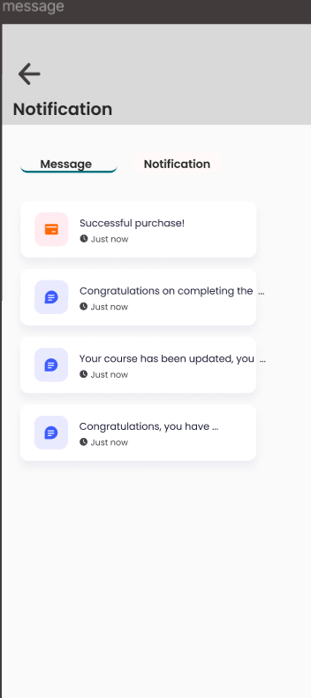
Notification Screen:
Displays real-time alerts for course updates, new messages, assignment deadlines, live session reminders, and achievements.
Each notification includes an icon, brief description, and timestamp, with the option to mark as read or view details.
